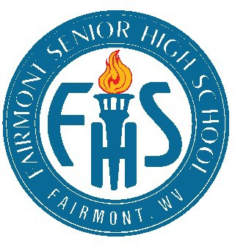
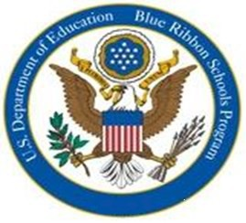
Fairmont Senior High School
1 Loop Park, Fairmont, WV 26554
Phone: 304-367-2150 ● Fax: 304-366-5988

A National Blue Ribbon School

Principal
James Green

Assistant Principal
Jamal Womble

Assistant Principal
Tracey Fluharty- Godfrey

School Counselors

Alisa Pelaez apelaez@k12.wv.us

Alex Eddy alex.eddy@k12.wv.us

Marion County
Board of Education 1516 Mary Lou Retton Dr Fairmont, WV 26554

President
Mary Jo Thomas

Members
Donna Costello Thomas Dragich James Saunders Richard Pellegrin

Superintendent of Schools
Dr. Donna Hage

SCHOOL & COMMUNITY DEMOGRAPHICS
Fairmont Senior High School is a comprehensive high school serving an estimated 800 students in grades nine through twelve. Approximately 80% of the students identify as Caucasian, 12% African-American, and 6% Multi-Racial, and 2% Hispanic/Latino. Approximately 36% of our students are identified as low- SES and receive free or reduced lunch.

We are located in North Central West Virginia. The strength of Fairmont Senior High School is based upon a cooperative working relationship with our shareholders – parents, students, teachers, and community members. Fairmont Senior is an important cornerstone of the community.

CURRICULUM OFFERINGS

The day is divided into seven 54-minute periods, and the school year consists of 180 days divided into two semesters. Students have an opportunity to earn three and a half credits each semester, seven credits each year. The minimum number of credits to graduate is twenty-four. A strong em- phasis is placed on writing, critical thinking, computation, creativity, problem solving, and team work.

The curriculum offers Advanced Placement (AP) courses in English Literature, United States His- tory, Government, Calculus, Statistics, Chemistry, Music Theory, and Computer Science. Dual enrollment courses offered at Fairmont Senior High School are College Algebra, College Trigo- nometry, College Biology, and College English. Students have the opportunity to attend the local university and/or community & technical college during their senior year and earn college credit.

GRADING
Fairmont Senior High School utilizes a state-wide, standards-based assessment during the spring semester. In order to receive credit for a course, students must consistently demonstrate proficiency in their assigned classes. Tutoring sessions are offered after school for students struggling with their coursework.

EXRACURRICULAR OFFERINGS

Fairmont Senior High School offers multiple special interest clubs including a number of service and honorary groups which all provide opportunities for extracurricular involvement. FSHS offers an outstanding Fine Arts program, which includes drama, art and both vocal and instrumental mu- sic. Our Fine Arts program has won numerous awards. The audition only, Advanced Vocal En- semble, the Madrigals, provides a renaissance-style performance in all shows and competitions.
Our superlative sports program encompasses 20 competitive teams at the varsity and junior varsity levels.

Colleges/Universities to which FSHS students have been accepted through 2021:  Alderson-Broaddus University Air Force Academy  Ava Maria University Berea College Bethany College  Bowling Green State University Brown University  Clarkson University Cleveland State University Concord University Dartmouth College  Davis & Elkins College Duquesne University  Eastern New Mexico University Fairmont State University Furman University Georgetown University Glenville State College  Johns Hopkins University  Kent State University  Marshall University  Mary Baldwin College Ohio State University Ohio Valley University  Pennsylvania State University Pierpont Community & Technical College  Point Park University Potomac State Shepherd University University of Akron  University of California, PA University of Charleston University of Kentucky  University of Pittsburgh University of South Carolina Wake Forest University Washington & Jefferson University  West Virginia Junior College West Liberty University West Virginia University West Virginia Wesleyan Wheeling Jesuit University Yale University | Class of 2022 Graduation Requirements
 | CATEGORIES | CREDITS | GRADING SCALE
 | ENGLISH LANGUAGE ARTS:  English 9, 9H, 10, 10H, 11, 12, AP English, or Dual Credit English course | 4 | Grade | Range
 |  |  | A | 90-100
 | MATHEMATICS:  Algebra I, Algebra I H, Algebra Support, Geometry, Geometry H. Financial Algebra, Applied Statistics, Algebra II, Algebra II H, Trig/Pre-Calculus, Trig/Pre-calculus H, or AP Calculus, AP Statistics, College Algebra, College Trigonometry | 4 | B | 80-89
 |  |  | C | 70-79
 |  |  | D | 60-69
 | SCIENCE:  Earth & Space Science, Earth and Space Science Honors, Biology or Biology Honors, Lab Science*, or AP Science* | 3 or 4
 |  |  | F | 0-59
Promotion Criteria
Students in every grade are expected to make regular progress toward graduation within a four-year period of time. The following are the standards for promotion:
 | SOCIAL STUDIES:  World Studies, U.S. Studies, Contemporary Stud-  ies, or AP US History, Civics, or AP Gov't/ Politics | 4
 | PHYSICAL EDUCATION | 1
 |  |  | Freshman (9th) | Promotion from middle school
 | HEALTH | 1
 |  |  | Sophomore (10th) | 5 credits at least 2 core)
 | FINE ARTS | 1
 |  |  | Junior (11th) | 11 credits
 | ELECTIVES | 6
 |  |  | Senior (12th) | 17 credits
 | TOTAL  ** 30 Volunteer hours are required** | 24

*Students choose science courses based on program of study. Science choices include Physical Science, Environmental
Science, Human Anatomy, Forensic Science, Forensic Science Honors, Dual Credit Forensics, Chemistry, AP Chemistry, College Biology, and Physics.

Three Year Trends-Average SAT Scores

Fairmont Senior High School vs. State of WV
 | Total Students Tested |  | Evidenced Based Reading and Writing |  | Mathematics |  | Total Score
Grad Year | School | State | School | State | School | State | School | State
2019 | 187 | 16,713 | 500 | 475 | 484 | 453 | 984 | 928
2020 | 109 | 5,706 | 526 | 512 | 497 | 479 | 1023 | 991
2021 | 142 | 14,580 | 479 | 476 | 466 | 453 | 945 | 928

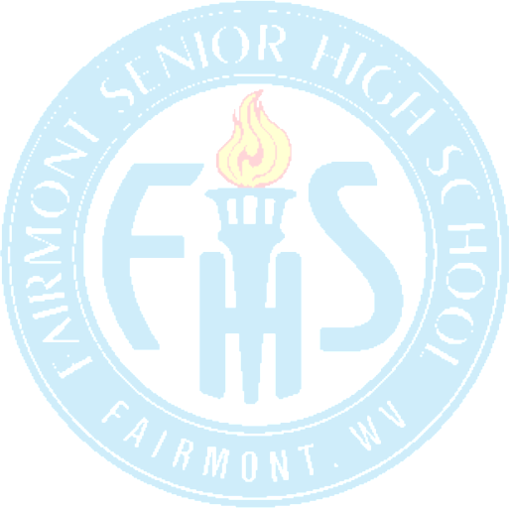
Mission Statement
Fairmont Senior High School remains an academic leader in preparing students for college and for the world of work. Our mission is to provide a safe, motivating work environment, a climate of high expectations, and a rigorous curriculum for ALL students. We believe in teaching and model- ing appropriate behaviors to aid in the mastery of grade level skills in ALL core areas. Creating and maintaining open lines of communication with parents and community stakeholders plays an important role towards our pursuit of rigor and excellence for ALL students.

